PRACTICAL FILE
DAA

MAYANK KUMAR

ROLL NO:-1816110111
CSE 2B (G2)

Program1: Write a Program to Perform Selection Sort
#include <stdio.h>
int main()
{
int a[100], n, i, j, position, swap;
printf("Enter number of elements\n");
scanf("%d", &n);
printf("Enter %d Numbers\n", n);
for (i = 0; i < n; i++)
{
position=i;
for(j = i + 1; j < n; j++)
{
if(a[position] > a[j])
position=j;
}
if(position != i)
{
swap=a[i];
a[i]=a[position];
a[position]=swap;
}
}
printf("Sorted Array:\n");
for(i = 0; i < n; i++)
printf(" %d ", a[i]);
return 0;
}

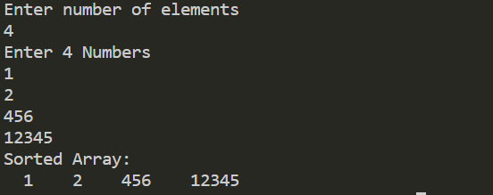

Program2 : Compare string using recursion

#include<iostream>
#include<conio.h>
#include<stdlib.h>
#include<string.h>
using namespace std;
int i=0;
int flag=0;
char a,b;
int comparestring(char c[],char d[] )
{
while(i<strlen(c)||i<strlen(d))
{
a=c[i];
b=d[i];
i++;
if(a!=b)
{
return flag=1;
}
else
{
return comparestring(c,d);
}
}

}
int main(void)
{
int f;
char x[100],y[100];
cin>>x;
cin>>y;
f=comparestring(x,y);
if(f==1)
{
cout<<"strings not equal";
}
else
{
cout<<"strings equal";
}
}
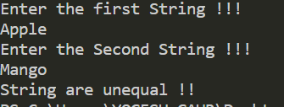

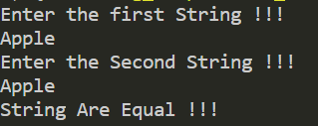

Program3: Copy string using recursion

#include <stdio.h>

void copy(char [], char [], int);

int main()
{
char str1[20], str2[20];

printf("Enter string to copy: ");
scanf("%[^\n]s", str1);
copy(str1, str2, 0);
printf("Copying success.\n");
printf("The first string is: %s\n", str1);
printf("The second string is: %s\n", str2);
return 0;
}

void copy(char str1[], char str2[], int index)
{
str2[index] = str1[index];
if (str1[index] == '\0')
return;
copy(str1, str2, index + 1);
}

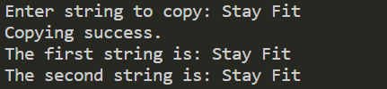

Program4: Write a Program To Perform a Heap Sort
#include<stdio.h>
int temp;
void heapify(int arr[], int size, int i)
{
int largest = i;
int left = 2*i + 1;
int right = 2*i + 2;

if (left < size && arr[left] >arr[largest])
largest = left;
if (right < size && arr[right] > arr[largest])
largest = right;
if (largest != i)
{
temp = arr[i];
arr[i]= arr[largest];
arr[largest] = temp;
heapify(arr, size, largest);
}
}
void heapSort(int arr[], int size)
{
int i;
for (i = size / 2 - 1; i >= 0; i--)
heapify(arr, size, i);
for (i=size-1; i>=0; i--)
{
temp = arr[0];
arr[0]= arr[i];
arr[i] = temp;
heapify(arr, i, 0);
}
}
Program5: Write a Program To Perform Linear Search
#include <stdio.h>
int RecursiveLS(int arr[], int value, int index, int n)
{
int pos = 0;
if(index >= n)
{
return 0;
}
else if (arr[index] == value)
{
pos = index + 1;
return pos;
}
else
{
return RecursiveLS(arr, value, index+1, n);
}
return pos;
}

int main()
{
int n, value, pos, m = 0, arr[100];
printf("Enter the total elements in the array ");
scanf("%d", &n);
printf("Enter the array elements\n");
for (int i = 0; i < n; i++)
{
scanf("%d", &arr[i]);
}

printf("Enter the element to search ");
scanf("%d", &value);
pos = RecursiveLS(arr, value, 0, n);
if (pos != 0)
{
printf("Element found at position %d ", pos);
}
else
{
printf("Element not found");
}
return 0;
}
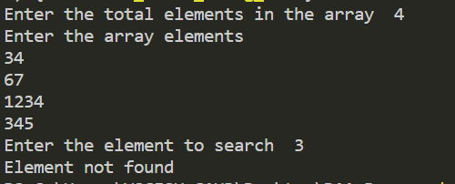

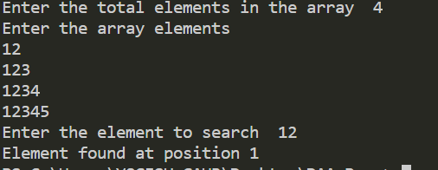

Program6: Write a Program to Perform Binary Search
#include <stdio.h>
void binary_search(int [], int, int, int);
void bubble_sort(int [], int)
int main()
{
int key, size, i;
int list[25];

printf("Enter the total elements in the array ");
scanf("%d", &size);
printf("Enter the array elements\n");
for(i = 0; i < size; i++)
{
scanf("%d",&list[i]);
}
bubble_sort(list, size);
printf("\n");
printf("Enter the element to search");
scanf("%d", &key);
binary_search(list, 0, size, key);

}

void bubble_sort(int list[], int size)
{
int temp, i, j;
for (i = 0; i < size; i++)
{
for (j = i; j < size; j++)
{
if (list[i] > list[j])
{
temp = list[i];
list[i] = list[j];
list[j] = temp;
}
}
}
}

void binary_search(int list[], int lo, int hi, int key)
{
int mid;

if (lo > hi)
{
printf("Element not found");
return;
}
mid = (lo + hi) / 2;
if (list[mid] == key)
{
printf("Element found at position %d",mid+1);
}
else if (list[mid] > key)
{
binary_search(list, lo, mid - 1, key);
}
else if (list[mid] < key)
{
binary_search(list, mid + 1, hi, key);
}
}

void main()
{
int arr[100],i,size;
printf("enter the Size Of Array :\n");
scanf("%d",&size);
printf("Enter the Array : \n");
for(i=0;i<size;i++){
scanf("%d",&arr[i]);
}

heapSort(arr, size);

printf("printing sorted elements\n");
for (i=0; i<size; ++i)
printf("%d\n",arr[i]);
}
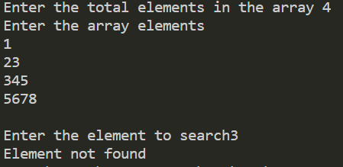
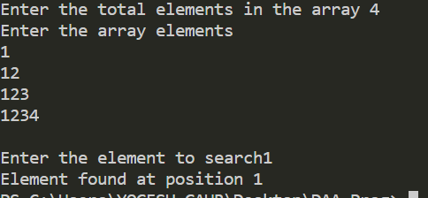
Program7: Write a Program to Perform Insertion Sort
#include <stdio.h>
#include<stdlib.h>

void insertionSort(int arr[], int n)
{
int i, key, j;
for (i = 1; i < n; i++)
{
key = arr[i];
j = i - 1;
while (j >= 0 && arr[j] > key)
{
arr[j + 1] = arr[j];
j = j - 1;
}
arr[j + 1] = key;
}
for (i = 0; i < n; i++)
{
printf("%d ",arr[i],"\n");
}
}

int main()
{
int *a, i, size, position;

printf("Enter the number of elements in array\n");
scanf("%d", &size);

a = (int *)malloc(sizeof(size));

printf("Enter %d numbers\n", size);

for (i = 0; i < size; i++){
scanf("%d", &a[i]);
}
printf("The sorted array is : \n");
insertionSort(a, size);
return 0;
}
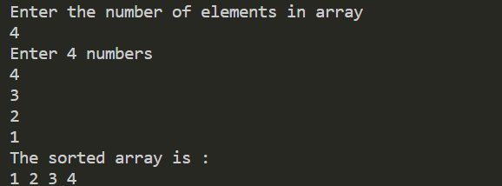

Program8: Write a Program to Perform Quick Sort
#include <stdio.h>
void quick_sort(int[],int,int);
int partition(int[],int,int);
int main()
{
int a[50],n,i;
printf("Enter the Size of Array : \n");
scanf("%d",&n);
printf("\nEnter array elements:");

for(i=0;i<n;i++)
scanf("%d",&a[i]);

quick_sort(a,0,n-1);
printf("\nArray after sorting:");

for(i=0;i<n;i++)
printf("%d ",a[i]);

return 0;
}

void quick_sort(int a[],int l,int u)
{
int j;
if(l<u)
{
j=partition(a,l,u);
quick_sort(a,l,j-1);
quick_sort(a,j+1,u);
}
}

int partition(int a[],int l,int u)
{
int v,i,j,temp;
v=a[l];
i=l;
j=u+1;

do
{
do
i++;

while(a[i]<v&&i<=u);

do
j--;
while(v<a[j]);

if(i<j)
{
temp=a[i];
a[i]=a[j];
a[j]=temp;
}
}while(i<j);

a[l]=a[j];
a[j]=v;
return(j);
}
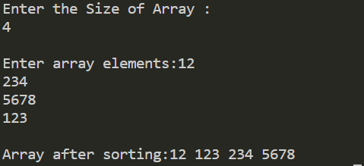

Program9: Write a Program to Perform Merge Sort
#include <stdio.h> ––––
void merge(int arr[], int l, int m, int r)
{
int i, j, k;
int n1 = m - l + 1;
int n2 = r - m;

int L[n1], R[n2];
for (i = 0; i < n1; i++)
L[i] = arr[l + i];
for (j = 0; j < n2; j++)
R[j] = arr[m + 1 + j];

i = 0;
j = 0;
k = l;
while (i < n1 && j < n2) {
if (L[i] <= R[j]) {
arr[k] = L[i];
i++;
}
else {
arr[k] = R[j];
j++;
}
k++;
}
while (i < n1) {
arr[k] = L[i];
i++;
k++;
}
while (j < n2) {
arr[k] = R[j];
j++;
k++;
}
}
void mergeSort(int arr[], int l, int r)
{
if (l < r) {

int m = l + (r - l) / 2;

mergeSort(arr, l, m);
mergeSort(arr, m + 1, r);

merge(arr, l, m, r);
}
}
void printArray(int A[], int size)
{
int i;
for (i = 0; i < size; i++)
printf("%d ", A[i]);
printf("\n");
}
int main()
{
int arr[30],i,arr_size;
printf("enter the number of element\n");

scanf("%d",&arr_size);
printf("enter the element\n");
for(i=0;i<arr_size;i++){
scanf("%d",&arr[i]);
}
printf("Given array is \n");
printArray(arr, arr_size);
mergeSort(arr, 0, arr_size - 1);
printf("\nSorted array is \n");
printArray(arr, arr_size);
return 0;
}

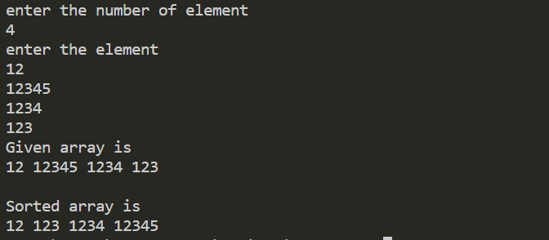

program 10. Write a program in C/C++ for FloydWarshall

#include <stdio.h>
main()
{
int dist[10][10],succ[10][10],n,i,j,k;
int newDist;

scanf("%d",&n);
for (i=0;i<n;i++)
for (j=0;j<n;j++)
{
dist[i][j]=999;
succ[i][j]=j;
}
while (1)
{
scanf("%d %d %d",&i,&j,&k);
if (i==(-1))
break;
dist[i][j]=k;
}
for (i=0;i<n;i++)
{
for (k=0;k<n;k++)
printf("%3d %d ",dist[i][k],succ[i][k]);
printf("\n");
}
printf("-------------------------------\n");
/* Floyd-Warshall */
for (j=0;j<n;j++)
{
for (i=0;i<n;i++)
if (dist[i][j]<999)
for (k=0;k<n;k++)
{
newDist=dist[i][j]+dist[j][k];
if (newDist<dist[i][k])
{
dist[i][k]=newDist;
succ[i][k]=succ[i][j];
}
}
for (i=0;i<n;i++)
{
for (k=0;k<n;k++)
printf("%3d %d ",dist[i][k],succ[i][k]);
printf("\n");
}
printf("-------------------------------\n");
}
for (i=0;i<n;i++)
for (j=0;j<n;j++)
if (dist[i][j]==999)
printf("No path from %d to %d\n",i,j);
else
{
printf("Distance %d for %d ",dist[i][j],i);
for (k=succ[i][j];
k!=j;
k=succ[k][j])
printf("%d ",k);
printf("%d\n",j);
}
}

OUTPUT:
